**Our mission**

*We are a team with experience in nanosatellites, control systems, propulsion and development of subsystems that begins under the auspices of the SUCHAI 2 & 3 Project of the University of Chile (*[*SPEL*](https://spel.cl/)*). We have been trained in simulation of the space environment at the University of Tokyo, Japan thanks to the SEELA program. Our missions are:*

* ~~Sell relatively low-cost products through a recycled manufacturing model.~~
* Serve quality services with reports of various simulations.
* Supply educational training based on experience.

Currently, our team members are part of the [PlantSat project](https://plantsat.spel.cl/), an international project in collaboration with [RocketLab](https://www.rocketlabusa.com/) and [Gomspace](https://gomspace.com/home.aspx).

## **SERVICES**

**CHECK OUR SATELLITE SERVICES**

#### [Mission plan simulation](http://localhost:63342/S3D-Site/index.html)

Support for mission analysis and planning with detailed summary

#### [Estimation algorithms](http://localhost:63342/S3D-Site/index.html)

Implementation of the EKF, QUEST and TRIAL methods for different types of sensors.

#### [Control algorithms](http://localhost:63342/S3D-Site/index.html)

PID, Fuzzy, Predictive and adaptive control design.

#### [Payload design](http://localhost:63342/S3D-Site/index.html)

Design of mechanical parts and electrical circuit.

#### [Analysis of electrical power in missions](http://localhost:63342/S3D-Site/index.html)

Design of mechanical parts and electrical circuit

#### [Support](http://localhost:63342/S3D-Site/index.html)

Support in the testing and integration stages

## **PRODUCTS**

**CHECK OUR PRODUCTS**

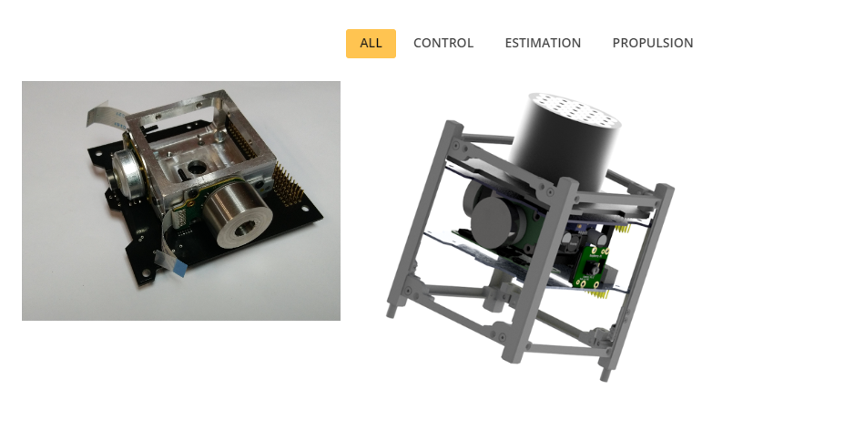

**Clients and collaboration**

Spel (Space and planetary exploration laboratory), ENAEX, CINT, Auroraspace, Aslight, GEA Spa

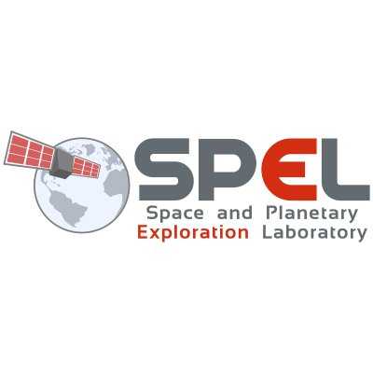

## 

Elias Obreque

Co-Founder & CEO

Aerospace Engineering

PhD Student in Electrical Engineering

Gustavo,

Co-Founder & CIO

Electrical Engineering

PhD Student

Jorge Orozco:

Consulting Engineer

## **CONTACT**

**CONTACT US**